Project 5

Part B:1 Draft

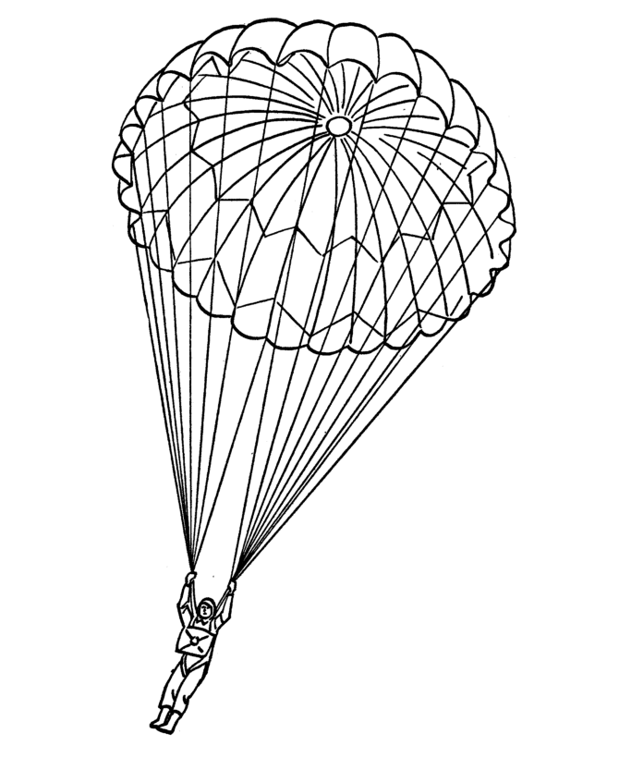

Ben Parsell

I’ve spent about 5 hours on this project so far with planning, coding, and bug smashing.